# Analysis of technologies used

To build the ui html, css has been the most broadly perceived other options yet there exist some better decisions today. Precise is one such framework which is maintained by Google and besides has a gigantic fashioner neighborhood.

A lot of instruments exist for backend progression. A couple of tongues and frameworks used are PHP, Python, Ruby on Rails, Laravel. For a web specialist development like Apache, Nginx are available other option. Close by this choice of database is similarly an issue. The best open decisions in any case are MySQL, PostgreSQL and MongoDB.

Notwithstanding the openness of alternatives, watching out for all of the improvement instruments decided to build the Social Awareness Website. There are some specific reasons taking into account which the above analyzed instruments are given tendency. The reasons are portrayed in the accompanying section.

# Tools or technologies

## Angular

It is used for UI development. Exact, conversely with various frameworks used for frontend is more straightforward to code and keep up taking into account its specific plan. Along these lines, a huge load of progress and upkeep cost will be saved.

## Express JS & NodeJS

They are used for the Rest API of application. NodeJS serves APIs as referenced by frontend which is inborn Angular, save data to informational index. NodeJS is flexible and less difficult to keep up. Express helps with caring for auth, middleware, etc with no issue.

## MongoDB

It is the informational collection used to accumulate user information during their conversation with the chatbot. Mongo Atlas a DB in cloud has been used for the comparable to decrease dependence on on-premise databases.

# Screenshot of running prototype

## Post Page

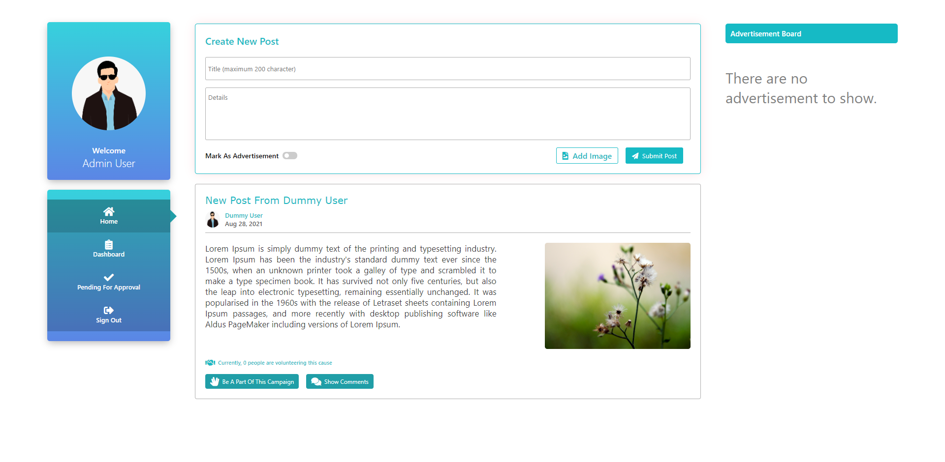

## Approve Post Page

